- Challenge Name and Category: ping-cmd (General Skills)
- Difficulty/Points: Easy
- Description: Can you make the server reveal its secrets? It seems to be able to ping Google DNS, but what happens if you get a little creative with your input? You can connect to the service here nc mysterious-sea.picoctf.net 54632
- Flag: picoCTF{p1nG_c0mm@nd_3xpL0it_su33essFuL_ddce97d3}
- Solution/Walkthrough: The first step is to connect to using nc mysterious-sea.picoctf.net 54632. The message appears “(We have tight security because we only allow '8.8.8.8'):” so well try to ping it. Once we do we can see that 2 packets were transmitted, received, with no packet loss.
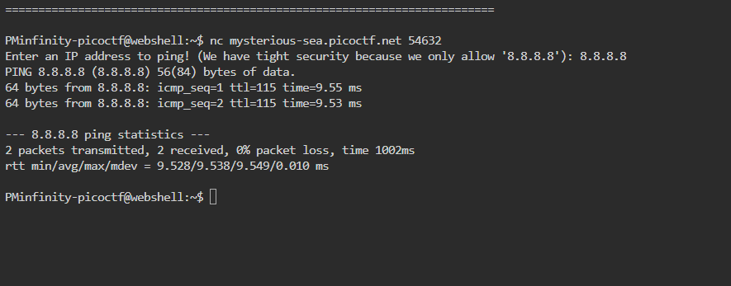
To see what information was contained in these packets we’ll have to ping the IP address again and use a second command, ls, to list these items.
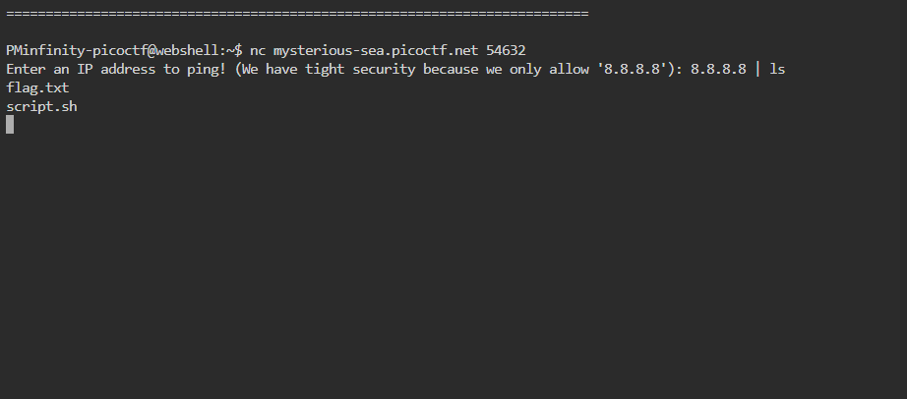
Now we can see the items contained within the packets. Now once more we will ping the IP 8.8.88 with a second command which will be cat flag.txt. The cat function will reveal our flag.
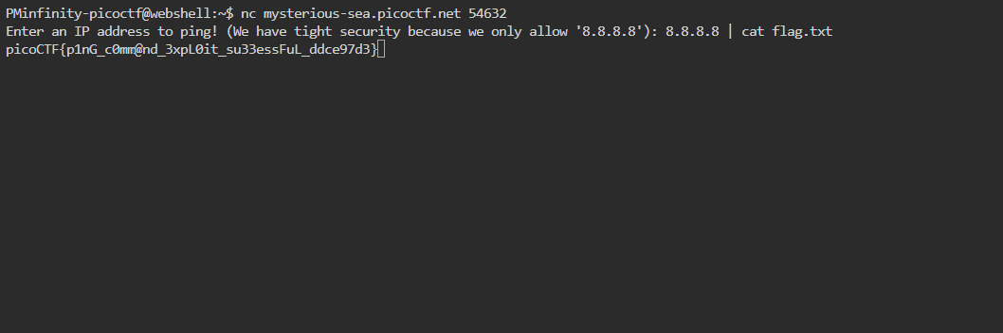
- Tools Used: Web Shell, Net Cat
- Hypothesis Formulation: using the ls functions and cat function to reveal the flag.
- What Worked vs. What Didn't: I found myself over thinking this CTF either know it covered content I am familiar with.

